**FUNCTIONAL REQUIREMENTS FOR VIRTUAL EVENT PLATFORM**

**a) End-User:**

**Features supported for the end user in the platform:**

1. Create and manage user profiles
2. View/Book available events
3. Register event
4. Make Payments
5. Cancel bookings/registrations
6. **Create and Manage User Profiles**

When you create a user profile, you do not have to re-enter the details of the user every time a user wants to register or book an event. Once a user provides its details and a profile is set up, the user needs to login in order to avail all functionalities provided on the platform. When a customer logs into the platform using their assigned ID and password, they gain access to the dashboard where they can make use of the platform functionalities.

1. **View/Book Available Events**

After creating the profile and logging into the account, the user can view all upcoming events that are registered on the platform. The event list will contain all event details like event description, timings etc. for each event. The end user can book any registered event they wish to attend by payment.

1. **Register Event**

The end user can register their upcoming business events on the platform. They can provide all details regarding to their event and make an event registration request which will be approved after successful payment. Registering their business events on the platform would help the business gain traction, visibility promotion. The user registering the event should also have the option of updating event details in case any unforeseen circumstances come forth.

1. **Make Payments**

Attending or registering events both require successful payment. The platform will have a robust payment interface guaranteeing secure payments. After providing event details users are then directed to the payment gateway where they can provide payment details.

1. **Cancel bookings/registrations**

Any unforeseen circumstances may arise therefore end users must have the option of cancelling their registrations or bookings and refund must be provided after cancellation

**Workflow:**

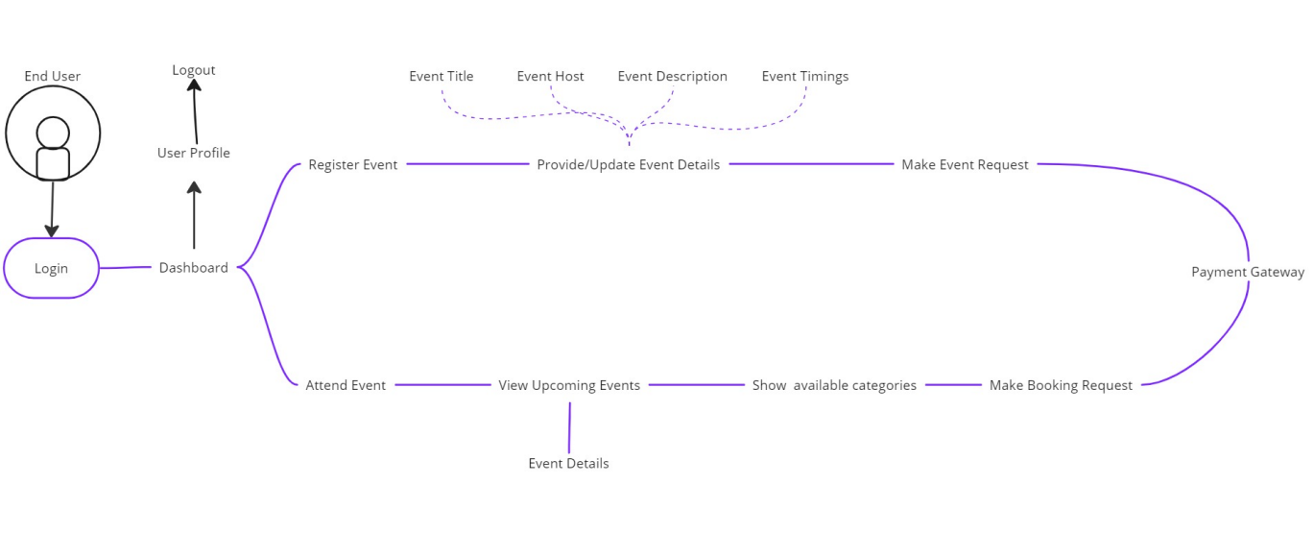

**Fig.1- End-User Workflow**

*Login->Dashboard->Register Event->Provide Event Details->Make Event Request->Payment Gateway*

or

*Login->Dashboard->Attend Event->View Upcoming Events->Show Available Categories->Make Booking Request->Payment Gateway*

or

*Login->Dashboard->User Profile->Logout*

|  |  |
| --- | --- |
| Dashboard | Views all available functionalities |
| User Profile | Users can view profile details, edit them or logout |
| Register Event | Users can register their upcoming events on the platform |
| Attend Event | Users can attend events registered on their platform |
| Payment Gateway | Allows user to make payments |

**b) Admin:**

**Features supported for admin on the platform:**

1. Login
2. View and manage user profiles
3. Networking Management
4. Event Management
5. Booking Management

**1. Login**

The admin logins to the website using the authorized id and password. If the admin logins successfully then they are taken to the Dashboard where they can manage the platform functions.

**2. View and manage user profiles**

The admin can monitor all the profiles of all the users who have registered on the platform, as well as the events registered or booked by them.

**3. Networking Management**

The admin keeps record of all the businesses and agencies which are associated with the platform. These businesses either register their events on the platform or help in promotion of the registered events.

**4. Event Management**

The admin manages all event requests on the platform. Once the admin receives the request ID he verifies the success of the payment and then add the event to the already registered events of the platform. He views the details such as event title, host, timings, description etc. for all registered events.

**5. Booking Management**

Admin manages all booking requests received on the platform. Users issue request to attend any of the upcoming events and the admin approves the request once he verifies the payment success. He also approves any cancellation requests.

**Workflow:**

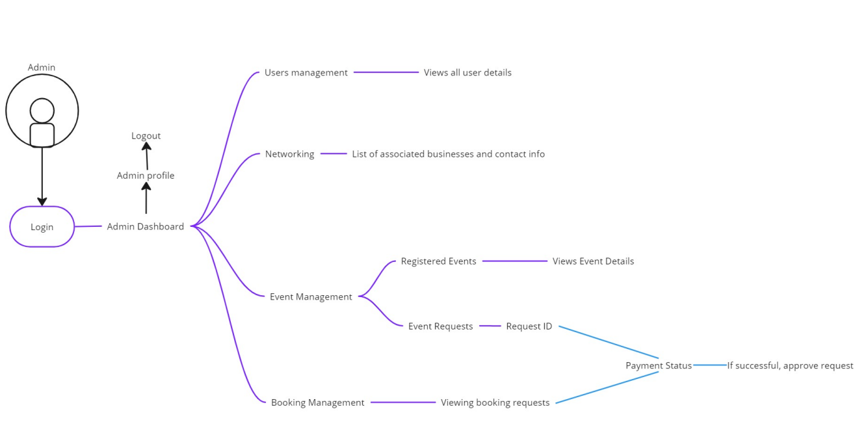

**Fig 2- Admin Workflow**

*Login->Dashboard->Users->User Details*

*Login->Dashboard->Network->Associate List-> Associate Details*

*Login->Dashboard->Events->Registered Events->View Event Details*

*Login->Dashboard->Events->Event Requests->Payment Status->Approve Request*

*Login->Dashboard->Bookings->Booking Requests->Payment Status->Approve Request*

*Login->Dashboard->Admin Profile->Logout*

|  |  |
| --- | --- |
| Dashboard | Views all available functionalities |
| Admin Profile | Admin can view profile details, edit them or logout |
| Users | Admin can view details of all user profiles |
| Network | Admin keeps track of all associated businesses |
| Events | Admin approves event requests and manages registered events |
| Bookings | Admin approves booking requests. |